**Hands on 1**

**Install Maven in Desktop**

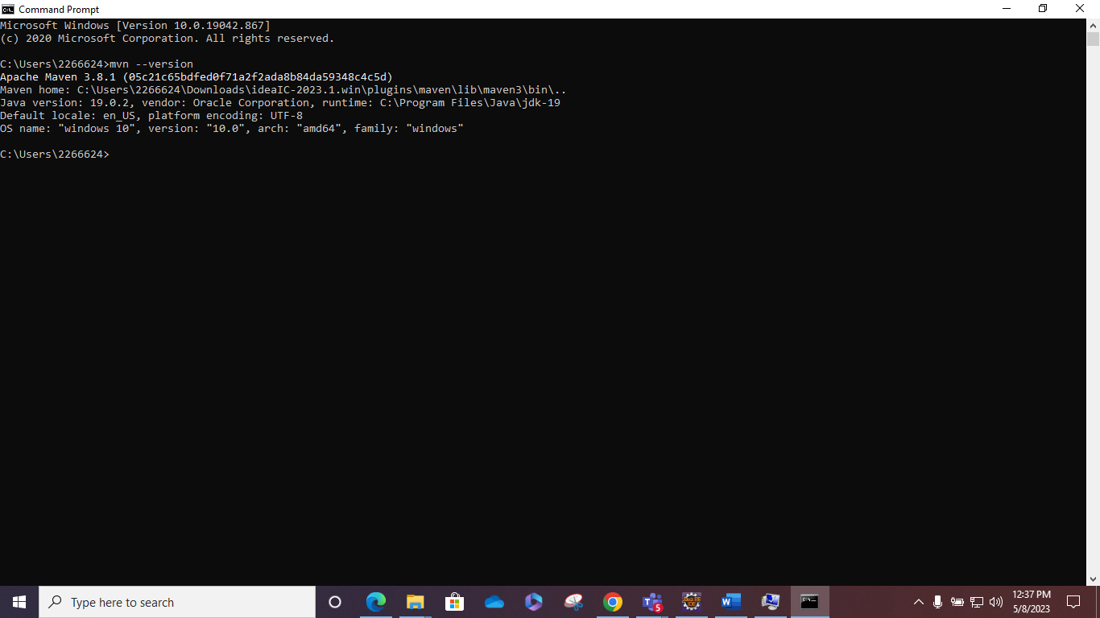

**Hands on 2**  
 **Create web project using Maven**   
   
  
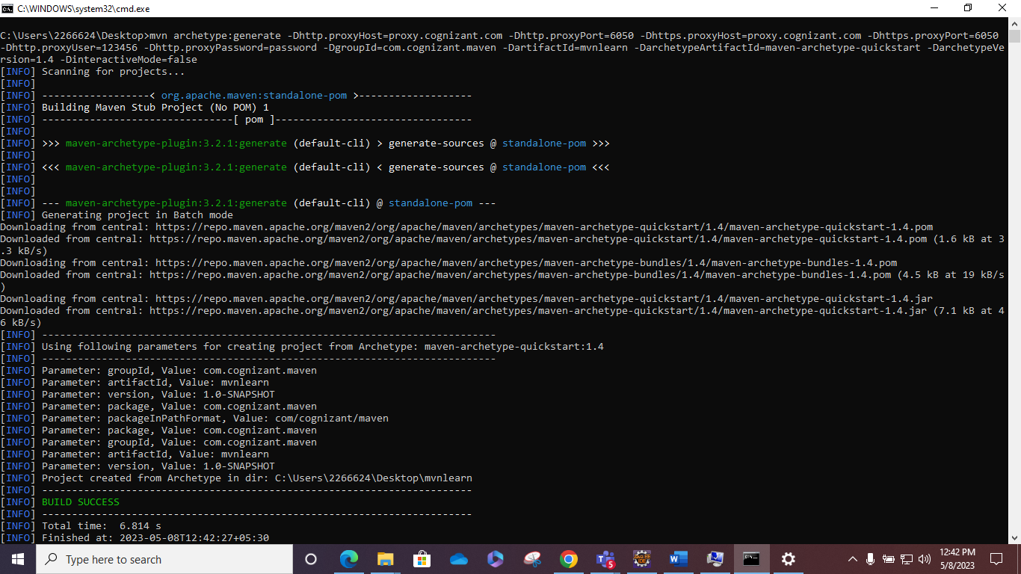

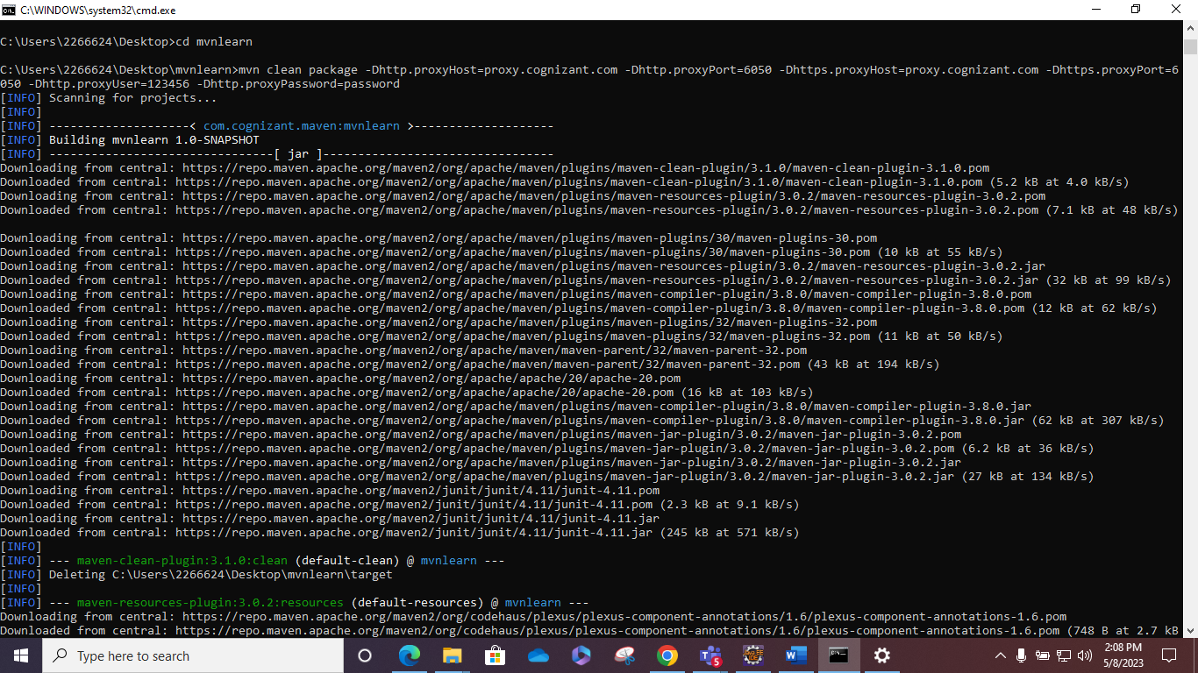

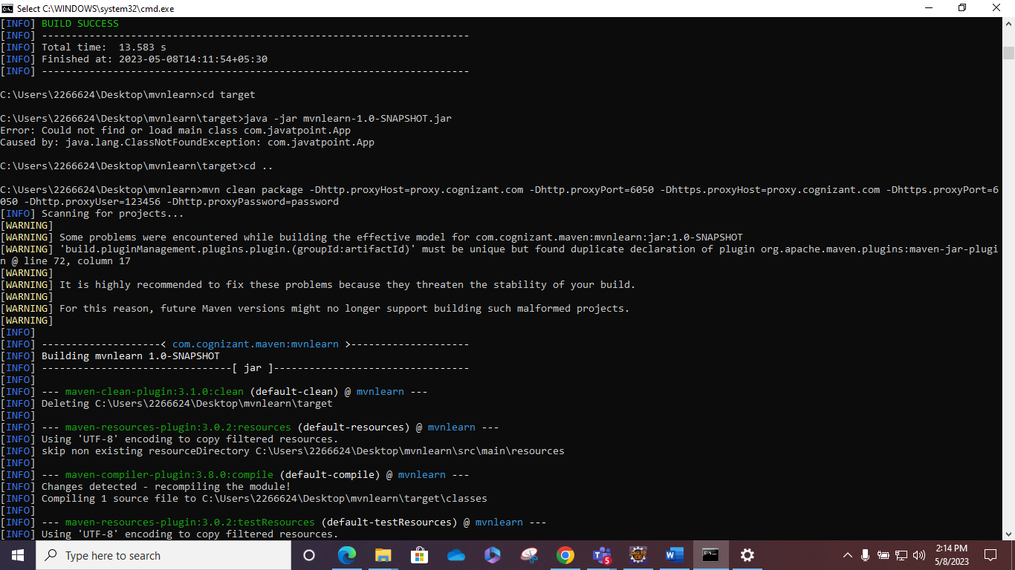

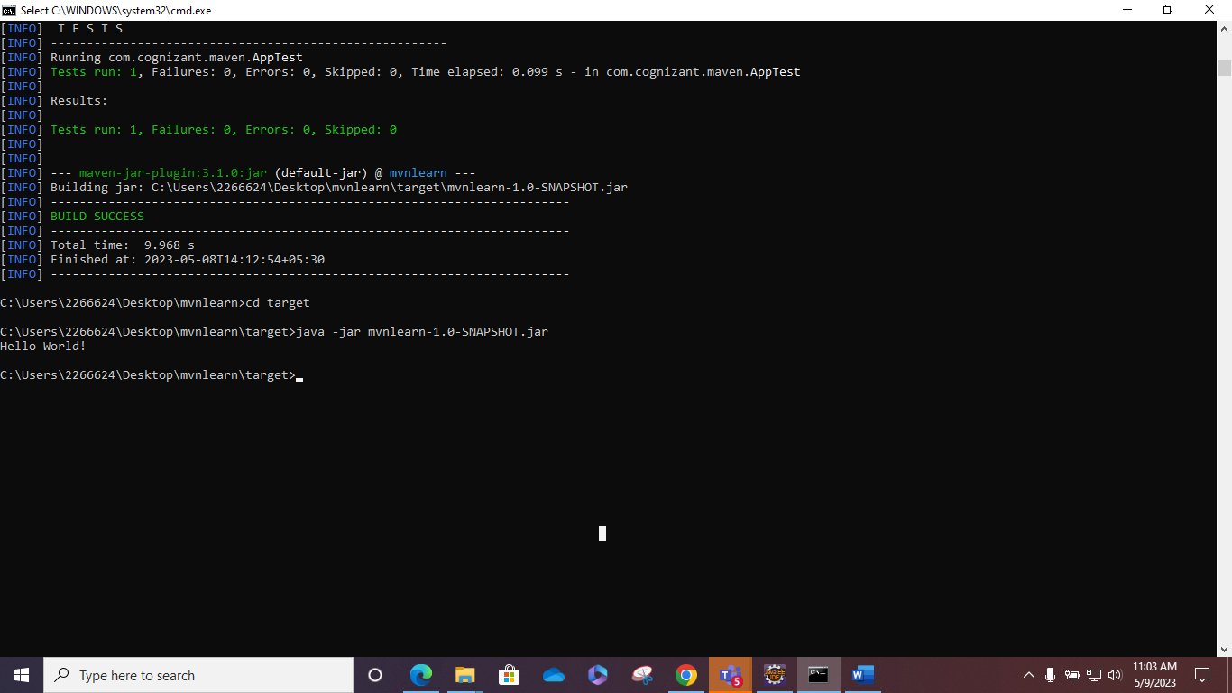

**Hands on 3**  
 **Setup Maven project in Eclipse**

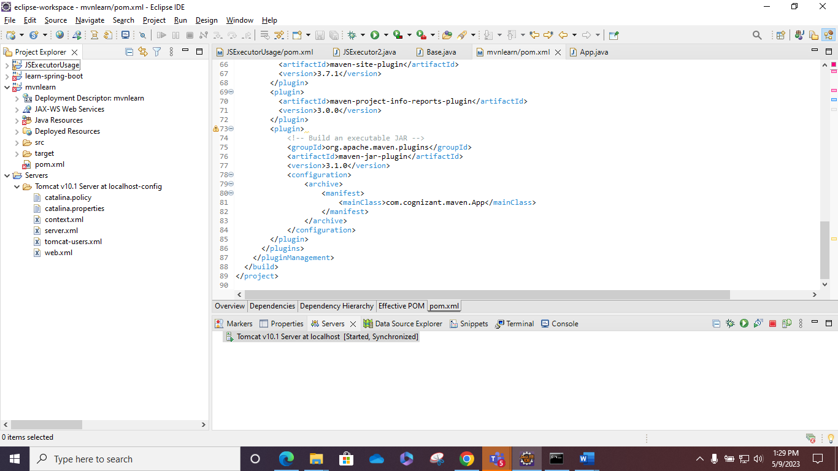

**Hands on 4**  
 **Understanding Maven Build Cycle and Goals**

